Homework 5

Diana Perez

9/11/2021

## R Markdown

This is an R Markdown document. Markdown is a simple formatting syntax for authoring HTML, PDF, and MS Word documents. For more details on using R Markdown see <http://rmarkdown.rstudio.com>.

When you click the **Knit** button a document will be generated that includes both content as well as the output of any embedded R code chunks within the document. You can embed an R code chunk like this:

library(vroom)  
library(wbstats)  
library(countrycode)  
library(tidyverse)

## Registered S3 methods overwritten by 'readr':  
## method from   
## as.data.frame.spec_tbl_df vroom  
## as_tibble.spec_tbl_df vroom  
## format.col_spec vroom  
## print.col_spec vroom  
## print.collector vroom  
## print.date_names vroom  
## print.locale vroom  
## str.col_spec vroom

## -- Attaching packages --------------------------------------- tidyverse 1.3.1 --

## v ggplot2 3.3.5 v purrr 0.3.4  
## v tibble 3.1.5 v dplyr 1.0.7  
## v tidyr 1.1.4 v stringr 1.4.0  
## v readr 2.0.2 v forcats 0.5.1

## -- Conflicts ------------------------------------------ tidyverse_conflicts() --  
## x readr::col_character() masks vroom::col_character()  
## x readr::col_date() masks vroom::col_date()  
## x readr::col_datetime() masks vroom::col_datetime()  
## x readr::col_double() masks vroom::col_double()  
## x readr::col_factor() masks vroom::col_factor()  
## x readr::col_guess() masks vroom::col_guess()  
## x readr::col_integer() masks vroom::col_integer()  
## x readr::col_logical() masks vroom::col_logical()  
## x readr::col_number() masks vroom::col_number()  
## x readr::col_skip() masks vroom::col_skip()  
## x readr::col_time() masks vroom::col_time()  
## x readr::cols() masks vroom::cols()  
## x readr::default_locale() masks vroom::default_locale()  
## x dplyr::filter() masks stats::filter()  
## x readr::fwf_cols() masks vroom::fwf_cols()  
## x readr::fwf_empty() masks vroom::fwf_empty()  
## x readr::fwf_positions() masks vroom::fwf_positions()  
## x readr::fwf_widths() masks vroom::fwf_widths()  
## x dplyr::lag() masks stats::lag()  
## x readr::locale() masks vroom::locale()  
## x readr::output_column() masks vroom::output_column()  
## x readr::problems() masks vroom::problems()

#import data  
tokyo <- vroom("https://raw.githubusercontent.com/chrit88/Bioinformatics_data/master/Workshop%205/Tokyo%202021%20medals.csv")

## Rows: 89 Columns: 4

## -- Column specification --------------------------------------------------------  
## Delimiter: ","  
## chr (1): Country  
## dbl (3): Gold, Silver, Bronze

##   
## i Use `spec()` to retrieve the full column specification for this data.  
## i Specify the column types or set `show_col_types = FALSE` to quiet this message.

##extract the GDP data for all countries  
GDP_data <- wb_data(indicator = "NY.GDP.PCAP.KD",   
 start= 2019,   
 end= 2019)  
  
## add a column to tokyo data containing the code  
tokyo$code <- countrycode(tokyo$Country,   
 origin = "country.name",   
 destination = "iso3c")

## Warning in countrycode_convert(sourcevar = sourcevar, origin = origin, destination = dest, : Some values were not matched unambiguously: Kosovo

##rename the 7th column so it works with the following code  
names(GDP_data)[5] <- "GDP"  
  
  
##correct CHINA  
tokyo$code[2] <- "CHN"  
  
## join the two data sets:  
tokyo_GDP <- left_join(tokyo,   
 GDP_data %>% select(iso3c, GDP),  
 by = c("code" = "iso3c"))  
##Add position column  
tokyo_GDP$position <- 1:nrow(tokyo_GDP)  
tokyo_GDP

## # A tibble: 89 x 7  
## Country Gold Silver Bronze code GDP position  
## <chr> <dbl> <dbl> <dbl> <chr> <dbl> <int>  
## 1 United States 39 41 33 USA 60837. 1  
## 2 Republic of China 38 32 18 CHN 10228. 2  
## 3 Japan 27 14 17 JPN 36362. 3  
## 4 Great Britain 22 21 22 GBR 46612. 4  
## 5 Russia 20 28 23 RUS 12123. 5  
## 6 Australia 17 7 22 AUS 58923. 6  
## 7 Germany 10 11 16 DEU 43312. 7  
## 8 Italy 10 10 20 ITA 32044. 8  
## 9 France 10 12 11 FRA 38897. 9  
## 10 Netherlands 10 12 14 NLD 48424. 10  
## # ... with 79 more rows

##Visualizing data  
ggplot(tokyo_GDP, aes(x=GDP, y=position)) +  
 geom_point() +  
 theme_bw() +  
 ylab("position") +   
 xlab("GDP")

## Warning: Removed 4 rows containing missing values (geom_point).

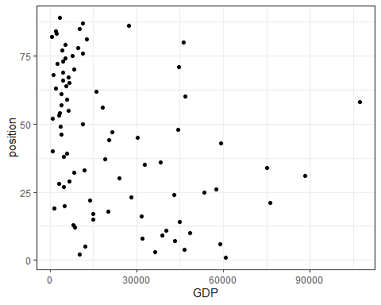

##fit a glm()  
mod1 <- glm(position ~ GDP,  
 data = tokyo_GDP,  
 family = "gaussian")  
plot(mod1)

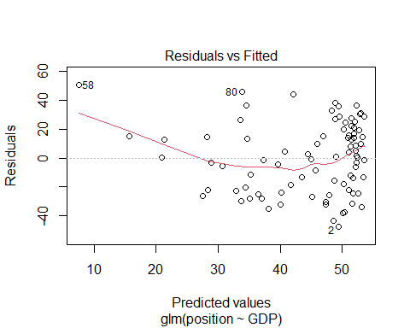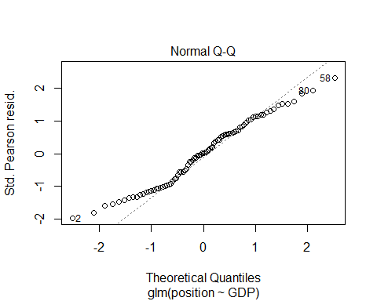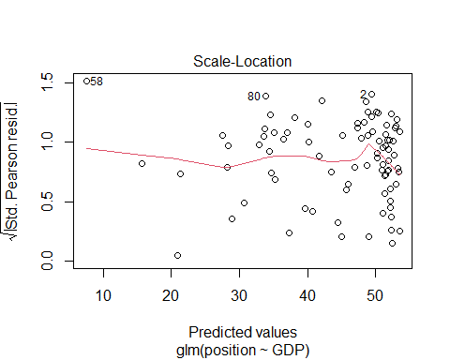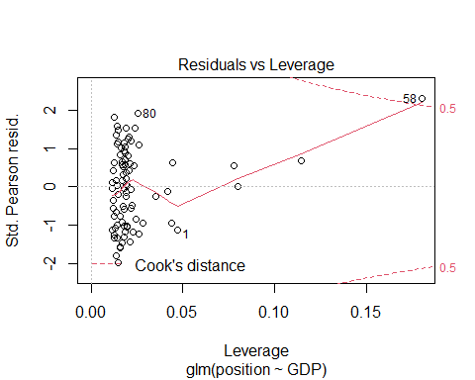

##Not a good model to represent the data  
##The residuals vs fitted show a clear trend  
## the normal Q-Q has some values that do not follow the dotted line  
##The residuals do not appear randomly distributed  
## There is a point outside de 0.5 line  
##Explore other models  
##fit a glm with a poisson distribution  
mod2 <- glm(position ~ GDP,  
 data = tokyo_GDP,  
 family = "poisson")  
plot(mod2)

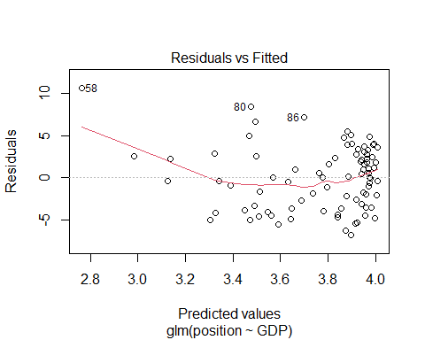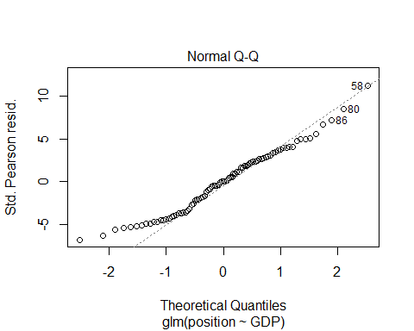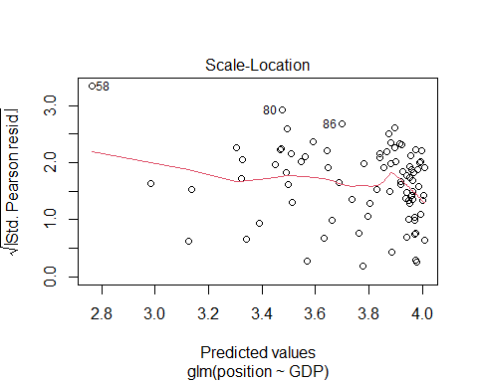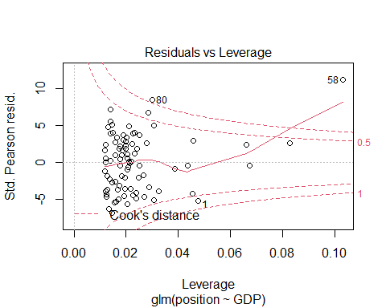

##fit a glm with a gaussian distribution with a log link  
mod3 <- glm(position ~ GDP,  
 data = tokyo_GDP,  
 family = gaussian(link= "log"))  
plot(mod3)

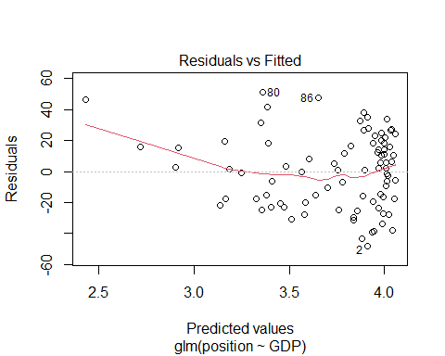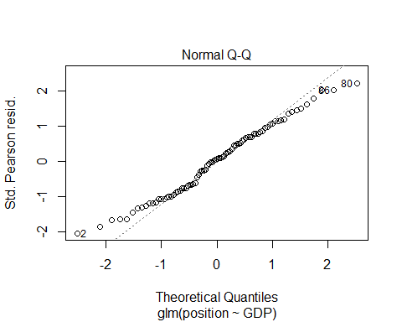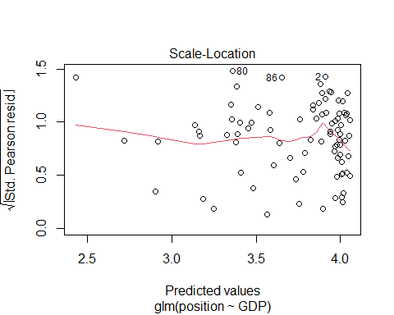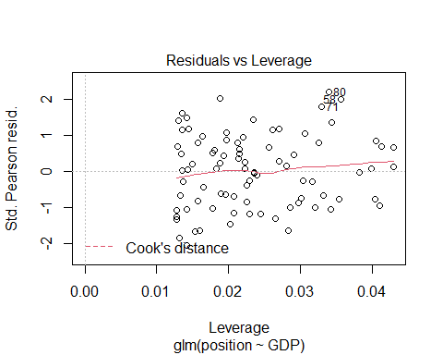

##guassian model with an inverse link  
mod4 <- glm(position ~ GDP,  
 data = tokyo_GDP,  
 family = gaussian(link = "inverse"))  
plot(mod4)

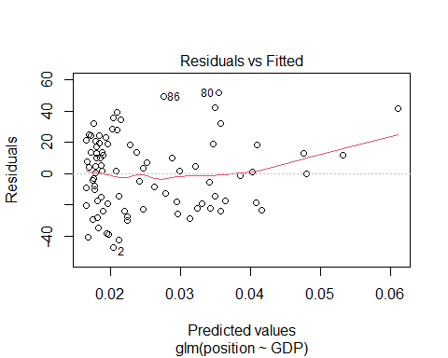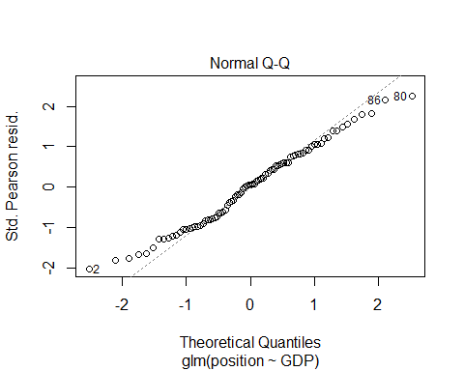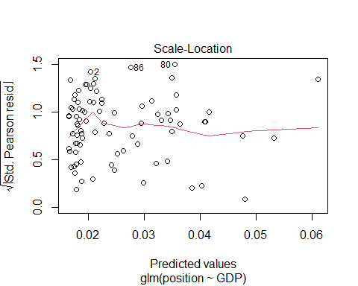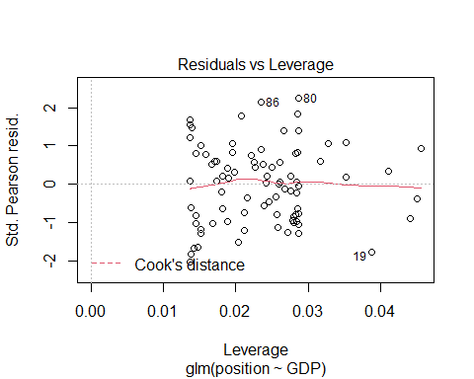

## inverse guassian model with an inverse link  
mod5 <- glm(position ~ GDP,  
 data = tokyo_GDP,  
 family = inverse.gaussian)  
plot(mod5)

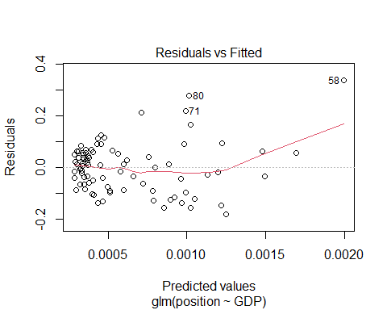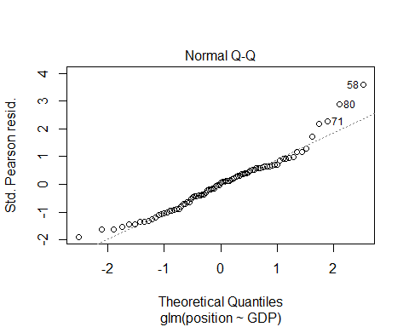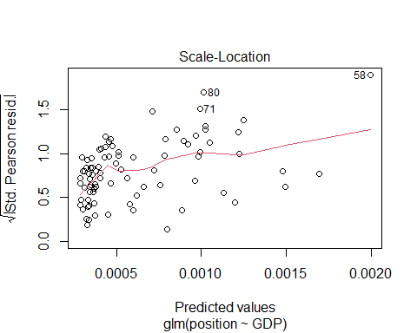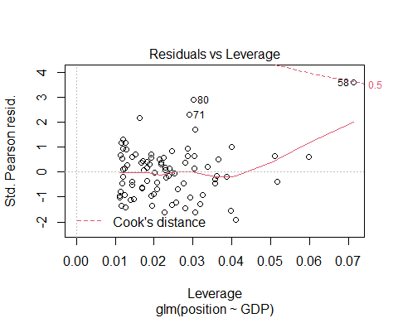

##transform data with log  
ggplot(tokyo_GDP, aes(x=GDP, y=position)) +  
 geom_point() +  
 scale_x_continuous(trans = 'log10') +  
 scale_y_continuous(trans = 'log10')

## Warning: Removed 4 rows containing missing values (geom_point).

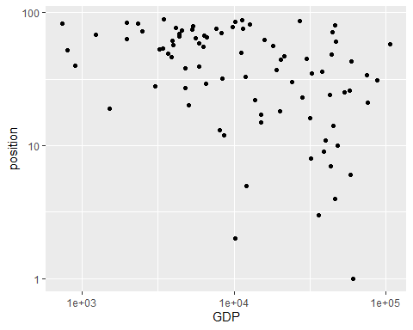

theme_bw() +  
 ggtitle("Logged Data")

## List of 93  
## $ line :List of 6  
## ..$ colour : chr "black"  
## ..$ size : num 0.5  
## ..$ linetype : num 1  
## ..$ lineend : chr "butt"  
## ..$ arrow : logi FALSE  
## ..$ inherit.blank: logi TRUE  
## ..- attr(*, "class")= chr [1:2] "element_line" "element"  
## $ rect :List of 5  
## ..$ fill : chr "white"  
## ..$ colour : chr "black"  
## ..$ size : num 0.5  
## ..$ linetype : num 1  
## ..$ inherit.blank: logi TRUE  
## ..- attr(*, "class")= chr [1:2] "element_rect" "element"  
## $ text :List of 11  
## ..$ family : chr ""  
## ..$ face : chr "plain"  
## ..$ colour : chr "black"  
## ..$ size : num 11  
## ..$ hjust : num 0.5  
## ..$ vjust : num 0.5  
## ..$ angle : num 0  
## ..$ lineheight : num 0.9  
## ..$ margin : 'margin' num [1:4] 0points 0points 0points 0points  
## .. ..- attr(*, "unit")= int 8  
## ..$ debug : logi FALSE  
## ..$ inherit.blank: logi TRUE  
## ..- attr(*, "class")= chr [1:2] "element_text" "element"  
## $ title : chr "Logged Data"  
## $ aspect.ratio : NULL  
## $ axis.title : NULL  
## $ axis.title.x :List of 11  
## ..$ family : NULL  
## ..$ face : NULL  
## ..$ colour : NULL  
## ..$ size : NULL  
## ..$ hjust : NULL  
## ..$ vjust : num 1  
## ..$ angle : NULL  
## ..$ lineheight : NULL  
## ..$ margin : 'margin' num [1:4] 2.75points 0points 0points 0points  
## .. ..- attr(*, "unit")= int 8  
## ..$ debug : NULL  
## ..$ inherit.blank: logi TRUE  
## ..- attr(*, "class")= chr [1:2] "element_text" "element"  
## $ axis.title.x.top :List of 11  
## ..$ family : NULL  
## ..$ face : NULL  
## ..$ colour : NULL  
## ..$ size : NULL  
## ..$ hjust : NULL  
## ..$ vjust : num 0  
## ..$ angle : NULL  
## ..$ lineheight : NULL  
## ..$ margin : 'margin' num [1:4] 0points 0points 2.75points 0points  
## .. ..- attr(*, "unit")= int 8  
## ..$ debug : NULL  
## ..$ inherit.blank: logi TRUE  
## ..- attr(*, "class")= chr [1:2] "element_text" "element"  
## $ axis.title.x.bottom : NULL  
## $ axis.title.y :List of 11  
## ..$ family : NULL  
## ..$ face : NULL  
## ..$ colour : NULL  
## ..$ size : NULL  
## ..$ hjust : NULL  
## ..$ vjust : num 1  
## ..$ angle : num 90  
## ..$ lineheight : NULL  
## ..$ margin : 'margin' num [1:4] 0points 2.75points 0points 0points  
## .. ..- attr(*, "unit")= int 8  
## ..$ debug : NULL  
## ..$ inherit.blank: logi TRUE  
## ..- attr(*, "class")= chr [1:2] "element_text" "element"  
## $ axis.title.y.left : NULL  
## $ axis.title.y.right :List of 11  
## ..$ family : NULL  
## ..$ face : NULL  
## ..$ colour : NULL  
## ..$ size : NULL  
## ..$ hjust : NULL  
## ..$ vjust : num 0  
## ..$ angle : num -90  
## ..$ lineheight : NULL  
## ..$ margin : 'margin' num [1:4] 0points 0points 0points 2.75points  
## .. ..- attr(*, "unit")= int 8  
## ..$ debug : NULL  
## ..$ inherit.blank: logi TRUE  
## ..- attr(*, "class")= chr [1:2] "element_text" "element"  
## $ axis.text :List of 11  
## ..$ family : NULL  
## ..$ face : NULL  
## ..$ colour : chr "grey30"  
## ..$ size : 'rel' num 0.8  
## ..$ hjust : NULL  
## ..$ vjust : NULL  
## ..$ angle : NULL  
## ..$ lineheight : NULL  
## ..$ margin : NULL  
## ..$ debug : NULL  
## ..$ inherit.blank: logi TRUE  
## ..- attr(*, "class")= chr [1:2] "element_text" "element"  
## $ axis.text.x :List of 11  
## ..$ family : NULL  
## ..$ face : NULL  
## ..$ colour : NULL  
## ..$ size : NULL  
## ..$ hjust : NULL  
## ..$ vjust : num 1  
## ..$ angle : NULL  
## ..$ lineheight : NULL  
## ..$ margin : 'margin' num [1:4] 2.2points 0points 0points 0points  
## .. ..- attr(*, "unit")= int 8  
## ..$ debug : NULL  
## ..$ inherit.blank: logi TRUE  
## ..- attr(*, "class")= chr [1:2] "element_text" "element"  
## $ axis.text.x.top :List of 11  
## ..$ family : NULL  
## ..$ face : NULL  
## ..$ colour : NULL  
## ..$ size : NULL  
## ..$ hjust : NULL  
## ..$ vjust : num 0  
## ..$ angle : NULL  
## ..$ lineheight : NULL  
## ..$ margin : 'margin' num [1:4] 0points 0points 2.2points 0points  
## .. ..- attr(*, "unit")= int 8  
## ..$ debug : NULL  
## ..$ inherit.blank: logi TRUE  
## ..- attr(*, "class")= chr [1:2] "element_text" "element"  
## $ axis.text.x.bottom : NULL  
## $ axis.text.y :List of 11  
## ..$ family : NULL  
## ..$ face : NULL  
## ..$ colour : NULL  
## ..$ size : NULL  
## ..$ hjust : num 1  
## ..$ vjust : NULL  
## ..$ angle : NULL  
## ..$ lineheight : NULL  
## ..$ margin : 'margin' num [1:4] 0points 2.2points 0points 0points  
## .. ..- attr(*, "unit")= int 8  
## ..$ debug : NULL  
## ..$ inherit.blank: logi TRUE  
## ..- attr(*, "class")= chr [1:2] "element_text" "element"  
## $ axis.text.y.left : NULL  
## $ axis.text.y.right :List of 11  
## ..$ family : NULL  
## ..$ face : NULL  
## ..$ colour : NULL  
## ..$ size : NULL  
## ..$ hjust : num 0  
## ..$ vjust : NULL  
## ..$ angle : NULL  
## ..$ lineheight : NULL  
## ..$ margin : 'margin' num [1:4] 0points 0points 0points 2.2points  
## .. ..- attr(*, "unit")= int 8  
## ..$ debug : NULL  
## ..$ inherit.blank: logi TRUE  
## ..- attr(*, "class")= chr [1:2] "element_text" "element"  
## $ axis.ticks :List of 6  
## ..$ colour : chr "grey20"  
## ..$ size : NULL  
## ..$ linetype : NULL  
## ..$ lineend : NULL  
## ..$ arrow : logi FALSE  
## ..$ inherit.blank: logi TRUE  
## ..- attr(*, "class")= chr [1:2] "element_line" "element"  
## $ axis.ticks.x : NULL  
## $ axis.ticks.x.top : NULL  
## $ axis.ticks.x.bottom : NULL  
## $ axis.ticks.y : NULL  
## $ axis.ticks.y.left : NULL  
## $ axis.ticks.y.right : NULL  
## $ axis.ticks.length : 'simpleUnit' num 2.75points  
## ..- attr(*, "unit")= int 8  
## $ axis.ticks.length.x : NULL  
## $ axis.ticks.length.x.top : NULL  
## $ axis.ticks.length.x.bottom: NULL  
## $ axis.ticks.length.y : NULL  
## $ axis.ticks.length.y.left : NULL  
## $ axis.ticks.length.y.right : NULL  
## $ axis.line : list()  
## ..- attr(*, "class")= chr [1:2] "element_blank" "element"  
## $ axis.line.x : NULL  
## $ axis.line.x.top : NULL  
## $ axis.line.x.bottom : NULL  
## $ axis.line.y : NULL  
## $ axis.line.y.left : NULL  
## $ axis.line.y.right : NULL  
## $ legend.background :List of 5  
## ..$ fill : NULL  
## ..$ colour : logi NA  
## ..$ size : NULL  
## ..$ linetype : NULL  
## ..$ inherit.blank: logi TRUE  
## ..- attr(*, "class")= chr [1:2] "element_rect" "element"  
## $ legend.margin : 'margin' num [1:4] 5.5points 5.5points 5.5points 5.5points  
## ..- attr(*, "unit")= int 8  
## $ legend.spacing : 'simpleUnit' num 11points  
## ..- attr(*, "unit")= int 8  
## $ legend.spacing.x : NULL  
## $ legend.spacing.y : NULL  
## $ legend.key :List of 5  
## ..$ fill : chr "white"  
## ..$ colour : logi NA  
## ..$ size : NULL  
## ..$ linetype : NULL  
## ..$ inherit.blank: logi TRUE  
## ..- attr(*, "class")= chr [1:2] "element_rect" "element"  
## $ legend.key.size : 'simpleUnit' num 1.2lines  
## ..- attr(*, "unit")= int 3  
## $ legend.key.height : NULL  
## $ legend.key.width : NULL  
## $ legend.text :List of 11  
## ..$ family : NULL  
## ..$ face : NULL  
## ..$ colour : NULL  
## ..$ size : 'rel' num 0.8  
## ..$ hjust : NULL  
## ..$ vjust : NULL  
## ..$ angle : NULL  
## ..$ lineheight : NULL  
## ..$ margin : NULL  
## ..$ debug : NULL  
## ..$ inherit.blank: logi TRUE  
## ..- attr(*, "class")= chr [1:2] "element_text" "element"  
## $ legend.text.align : NULL  
## $ legend.title :List of 11  
## ..$ family : NULL  
## ..$ face : NULL  
## ..$ colour : NULL  
## ..$ size : NULL  
## ..$ hjust : num 0  
## ..$ vjust : NULL  
## ..$ angle : NULL  
## ..$ lineheight : NULL  
## ..$ margin : NULL  
## ..$ debug : NULL  
## ..$ inherit.blank: logi TRUE  
## ..- attr(*, "class")= chr [1:2] "element_text" "element"  
## $ legend.title.align : NULL  
## $ legend.position : chr "right"  
## $ legend.direction : NULL  
## $ legend.justification : chr "center"  
## $ legend.box : NULL  
## $ legend.box.just : NULL  
## $ legend.box.margin : 'margin' num [1:4] 0cm 0cm 0cm 0cm  
## ..- attr(*, "unit")= int 1  
## $ legend.box.background : list()  
## ..- attr(*, "class")= chr [1:2] "element_blank" "element"  
## $ legend.box.spacing : 'simpleUnit' num 11points  
## ..- attr(*, "unit")= int 8  
## $ panel.background :List of 5  
## ..$ fill : chr "white"  
## ..$ colour : logi NA  
## ..$ size : NULL  
## ..$ linetype : NULL  
## ..$ inherit.blank: logi TRUE  
## ..- attr(*, "class")= chr [1:2] "element_rect" "element"  
## $ panel.border :List of 5  
## ..$ fill : logi NA  
## ..$ colour : chr "grey20"  
## ..$ size : NULL  
## ..$ linetype : NULL  
## ..$ inherit.blank: logi TRUE  
## ..- attr(*, "class")= chr [1:2] "element_rect" "element"  
## $ panel.spacing : 'simpleUnit' num 5.5points  
## ..- attr(*, "unit")= int 8  
## $ panel.spacing.x : NULL  
## $ panel.spacing.y : NULL  
## $ panel.grid :List of 6  
## ..$ colour : chr "grey92"  
## ..$ size : NULL  
## ..$ linetype : NULL  
## ..$ lineend : NULL  
## ..$ arrow : logi FALSE  
## ..$ inherit.blank: logi TRUE  
## ..- attr(*, "class")= chr [1:2] "element_line" "element"  
## $ panel.grid.major : NULL  
## $ panel.grid.minor :List of 6  
## ..$ colour : NULL  
## ..$ size : 'rel' num 0.5  
## ..$ linetype : NULL  
## ..$ lineend : NULL  
## ..$ arrow : logi FALSE  
## ..$ inherit.blank: logi TRUE  
## ..- attr(*, "class")= chr [1:2] "element_line" "element"  
## $ panel.grid.major.x : NULL  
## $ panel.grid.major.y : NULL  
## $ panel.grid.minor.x : NULL  
## $ panel.grid.minor.y : NULL  
## $ panel.ontop : logi FALSE  
## $ plot.background :List of 5  
## ..$ fill : NULL  
## ..$ colour : chr "white"  
## ..$ size : NULL  
## ..$ linetype : NULL  
## ..$ inherit.blank: logi TRUE  
## ..- attr(*, "class")= chr [1:2] "element_rect" "element"  
## $ plot.title :List of 11  
## ..$ family : NULL  
## ..$ face : NULL  
## ..$ colour : NULL  
## ..$ size : 'rel' num 1.2  
## ..$ hjust : num 0  
## ..$ vjust : num 1  
## ..$ angle : NULL  
## ..$ lineheight : NULL  
## ..$ margin : 'margin' num [1:4] 0points 0points 5.5points 0points  
## .. ..- attr(*, "unit")= int 8  
## ..$ debug : NULL  
## ..$ inherit.blank: logi TRUE  
## ..- attr(*, "class")= chr [1:2] "element_text" "element"  
## $ plot.title.position : chr "panel"  
## $ plot.subtitle :List of 11  
## ..$ family : NULL  
## ..$ face : NULL  
## ..$ colour : NULL  
## ..$ size : NULL  
## ..$ hjust : num 0  
## ..$ vjust : num 1  
## ..$ angle : NULL  
## ..$ lineheight : NULL  
## ..$ margin : 'margin' num [1:4] 0points 0points 5.5points 0points  
## .. ..- attr(*, "unit")= int 8  
## ..$ debug : NULL  
## ..$ inherit.blank: logi TRUE  
## ..- attr(*, "class")= chr [1:2] "element_text" "element"  
## $ plot.caption :List of 11  
## ..$ family : NULL  
## ..$ face : NULL  
## ..$ colour : NULL  
## ..$ size : 'rel' num 0.8  
## ..$ hjust : num 1  
## ..$ vjust : num 1  
## ..$ angle : NULL  
## ..$ lineheight : NULL  
## ..$ margin : 'margin' num [1:4] 5.5points 0points 0points 0points  
## .. ..- attr(*, "unit")= int 8  
## ..$ debug : NULL  
## ..$ inherit.blank: logi TRUE  
## ..- attr(*, "class")= chr [1:2] "element_text" "element"  
## $ plot.caption.position : chr "panel"  
## $ plot.tag :List of 11  
## ..$ family : NULL  
## ..$ face : NULL  
## ..$ colour : NULL  
## ..$ size : 'rel' num 1.2  
## ..$ hjust : num 0.5  
## ..$ vjust : num 0.5  
## ..$ angle : NULL  
## ..$ lineheight : NULL  
## ..$ margin : NULL  
## ..$ debug : NULL  
## ..$ inherit.blank: logi TRUE  
## ..- attr(*, "class")= chr [1:2] "element_text" "element"  
## $ plot.tag.position : chr "topleft"  
## $ plot.margin : 'margin' num [1:4] 5.5points 5.5points 5.5points 5.5points  
## ..- attr(*, "unit")= int 8  
## $ strip.background :List of 5  
## ..$ fill : chr "grey85"  
## ..$ colour : chr "grey20"  
## ..$ size : NULL  
## ..$ linetype : NULL  
## ..$ inherit.blank: logi TRUE  
## ..- attr(*, "class")= chr [1:2] "element_rect" "element"  
## $ strip.background.x : NULL  
## $ strip.background.y : NULL  
## $ strip.placement : chr "inside"  
## $ strip.text :List of 11  
## ..$ family : NULL  
## ..$ face : NULL  
## ..$ colour : chr "grey10"  
## ..$ size : 'rel' num 0.8  
## ..$ hjust : NULL  
## ..$ vjust : NULL  
## ..$ angle : NULL  
## ..$ lineheight : NULL  
## ..$ margin : 'margin' num [1:4] 4.4points 4.4points 4.4points 4.4points  
## .. ..- attr(*, "unit")= int 8  
## ..$ debug : NULL  
## ..$ inherit.blank: logi TRUE  
## ..- attr(*, "class")= chr [1:2] "element_text" "element"  
## $ strip.text.x : NULL  
## $ strip.text.y :List of 11  
## ..$ family : NULL  
## ..$ face : NULL  
## ..$ colour : NULL  
## ..$ size : NULL  
## ..$ hjust : NULL  
## ..$ vjust : NULL  
## ..$ angle : num -90  
## ..$ lineheight : NULL  
## ..$ margin : NULL  
## ..$ debug : NULL  
## ..$ inherit.blank: logi TRUE  
## ..- attr(*, "class")= chr [1:2] "element_text" "element"  
## $ strip.switch.pad.grid : 'simpleUnit' num 2.75points  
## ..- attr(*, "unit")= int 8  
## $ strip.switch.pad.wrap : 'simpleUnit' num 2.75points  
## ..- attr(*, "unit")= int 8  
## $ strip.text.y.left :List of 11  
## ..$ family : NULL  
## ..$ face : NULL  
## ..$ colour : NULL  
## ..$ size : NULL  
## ..$ hjust : NULL  
## ..$ vjust : NULL  
## ..$ angle : num 90  
## ..$ lineheight : NULL  
## ..$ margin : NULL  
## ..$ debug : NULL  
## ..$ inherit.blank: logi TRUE  
## ..- attr(*, "class")= chr [1:2] "element_text" "element"  
## - attr(*, "class")= chr [1:2] "theme" "gg"  
## - attr(*, "complete")= logi TRUE  
## - attr(*, "validate")= logi TRUE

##transform data with sqrt  
 ggplot(tokyo_GDP, aes(x=GDP, y=position)) +  
 geom_point() +  
 scale_x_sqrt() +  
 scale_y_sqrt()

## Warning: Removed 4 rows containing missing values (geom_point).

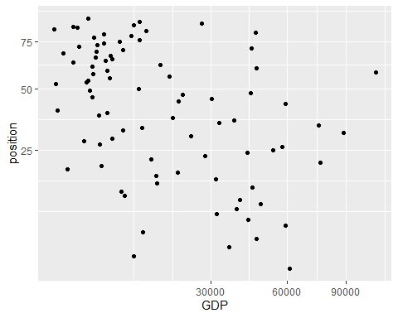

theme_bw() +  
 ggtitle("Sqrt Data")

## List of 93  
## $ line :List of 6  
## ..$ colour : chr "black"  
## ..$ size : num 0.5  
## ..$ linetype : num 1  
## ..$ lineend : chr "butt"  
## ..$ arrow : logi FALSE  
## ..$ inherit.blank: logi TRUE  
## ..- attr(*, "class")= chr [1:2] "element_line" "element"  
## $ rect :List of 5  
## ..$ fill : chr "white"  
## ..$ colour : chr "black"  
## ..$ size : num 0.5  
## ..$ linetype : num 1  
## ..$ inherit.blank: logi TRUE  
## ..- attr(*, "class")= chr [1:2] "element_rect" "element"  
## $ text :List of 11  
## ..$ family : chr ""  
## ..$ face : chr "plain"  
## ..$ colour : chr "black"  
## ..$ size : num 11  
## ..$ hjust : num 0.5  
## ..$ vjust : num 0.5  
## ..$ angle : num 0  
## ..$ lineheight : num 0.9  
## ..$ margin : 'margin' num [1:4] 0points 0points 0points 0points  
## .. ..- attr(*, "unit")= int 8  
## ..$ debug : logi FALSE  
## ..$ inherit.blank: logi TRUE  
## ..- attr(*, "class")= chr [1:2] "element_text" "element"  
## $ title : chr "Sqrt Data"  
## $ aspect.ratio : NULL  
## $ axis.title : NULL  
## $ axis.title.x :List of 11  
## ..$ family : NULL  
## ..$ face : NULL  
## ..$ colour : NULL  
## ..$ size : NULL  
## ..$ hjust : NULL  
## ..$ vjust : num 1  
## ..$ angle : NULL  
## ..$ lineheight : NULL  
## ..$ margin : 'margin' num [1:4] 2.75points 0points 0points 0points  
## .. ..- attr(*, "unit")= int 8  
## ..$ debug : NULL  
## ..$ inherit.blank: logi TRUE  
## ..- attr(*, "class")= chr [1:2] "element_text" "element"  
## $ axis.title.x.top :List of 11  
## ..$ family : NULL  
## ..$ face : NULL  
## ..$ colour : NULL  
## ..$ size : NULL  
## ..$ hjust : NULL  
## ..$ vjust : num 0  
## ..$ angle : NULL  
## ..$ lineheight : NULL  
## ..$ margin : 'margin' num [1:4] 0points 0points 2.75points 0points  
## .. ..- attr(*, "unit")= int 8  
## ..$ debug : NULL  
## ..$ inherit.blank: logi TRUE  
## ..- attr(*, "class")= chr [1:2] "element_text" "element"  
## $ axis.title.x.bottom : NULL  
## $ axis.title.y :List of 11  
## ..$ family : NULL  
## ..$ face : NULL  
## ..$ colour : NULL  
## ..$ size : NULL  
## ..$ hjust : NULL  
## ..$ vjust : num 1  
## ..$ angle : num 90  
## ..$ lineheight : NULL  
## ..$ margin : 'margin' num [1:4] 0points 2.75points 0points 0points  
## .. ..- attr(*, "unit")= int 8  
## ..$ debug : NULL  
## ..$ inherit.blank: logi TRUE  
## ..- attr(*, "class")= chr [1:2] "element_text" "element"  
## $ axis.title.y.left : NULL  
## $ axis.title.y.right :List of 11  
## ..$ family : NULL  
## ..$ face : NULL  
## ..$ colour : NULL  
## ..$ size : NULL  
## ..$ hjust : NULL  
## ..$ vjust : num 0  
## ..$ angle : num -90  
## ..$ lineheight : NULL  
## ..$ margin : 'margin' num [1:4] 0points 0points 0points 2.75points  
## .. ..- attr(*, "unit")= int 8  
## ..$ debug : NULL  
## ..$ inherit.blank: logi TRUE  
## ..- attr(*, "class")= chr [1:2] "element_text" "element"  
## $ axis.text :List of 11  
## ..$ family : NULL  
## ..$ face : NULL  
## ..$ colour : chr "grey30"  
## ..$ size : 'rel' num 0.8  
## ..$ hjust : NULL  
## ..$ vjust : NULL  
## ..$ angle : NULL  
## ..$ lineheight : NULL  
## ..$ margin : NULL  
## ..$ debug : NULL  
## ..$ inherit.blank: logi TRUE  
## ..- attr(*, "class")= chr [1:2] "element_text" "element"  
## $ axis.text.x :List of 11  
## ..$ family : NULL  
## ..$ face : NULL  
## ..$ colour : NULL  
## ..$ size : NULL  
## ..$ hjust : NULL  
## ..$ vjust : num 1  
## ..$ angle : NULL  
## ..$ lineheight : NULL  
## ..$ margin : 'margin' num [1:4] 2.2points 0points 0points 0points  
## .. ..- attr(*, "unit")= int 8  
## ..$ debug : NULL  
## ..$ inherit.blank: logi TRUE  
## ..- attr(*, "class")= chr [1:2] "element_text" "element"  
## $ axis.text.x.top :List of 11  
## ..$ family : NULL  
## ..$ face : NULL  
## ..$ colour : NULL  
## ..$ size : NULL  
## ..$ hjust : NULL  
## ..$ vjust : num 0  
## ..$ angle : NULL  
## ..$ lineheight : NULL  
## ..$ margin : 'margin' num [1:4] 0points 0points 2.2points 0points  
## .. ..- attr(*, "unit")= int 8  
## ..$ debug : NULL  
## ..$ inherit.blank: logi TRUE  
## ..- attr(*, "class")= chr [1:2] "element_text" "element"  
## $ axis.text.x.bottom : NULL  
## $ axis.text.y :List of 11  
## ..$ family : NULL  
## ..$ face : NULL  
## ..$ colour : NULL  
## ..$ size : NULL  
## ..$ hjust : num 1  
## ..$ vjust : NULL  
## ..$ angle : NULL  
## ..$ lineheight : NULL  
## ..$ margin : 'margin' num [1:4] 0points 2.2points 0points 0points  
## .. ..- attr(*, "unit")= int 8  
## ..$ debug : NULL  
## ..$ inherit.blank: logi TRUE  
## ..- attr(*, "class")= chr [1:2] "element_text" "element"  
## $ axis.text.y.left : NULL  
## $ axis.text.y.right :List of 11  
## ..$ family : NULL  
## ..$ face : NULL  
## ..$ colour : NULL  
## ..$ size : NULL  
## ..$ hjust : num 0  
## ..$ vjust : NULL  
## ..$ angle : NULL  
## ..$ lineheight : NULL  
## ..$ margin : 'margin' num [1:4] 0points 0points 0points 2.2points  
## .. ..- attr(*, "unit")= int 8  
## ..$ debug : NULL  
## ..$ inherit.blank: logi TRUE  
## ..- attr(*, "class")= chr [1:2] "element_text" "element"  
## $ axis.ticks :List of 6  
## ..$ colour : chr "grey20"  
## ..$ size : NULL  
## ..$ linetype : NULL  
## ..$ lineend : NULL  
## ..$ arrow : logi FALSE  
## ..$ inherit.blank: logi TRUE  
## ..- attr(*, "class")= chr [1:2] "element_line" "element"  
## $ axis.ticks.x : NULL  
## $ axis.ticks.x.top : NULL  
## $ axis.ticks.x.bottom : NULL  
## $ axis.ticks.y : NULL  
## $ axis.ticks.y.left : NULL  
## $ axis.ticks.y.right : NULL  
## $ axis.ticks.length : 'simpleUnit' num 2.75points  
## ..- attr(*, "unit")= int 8  
## $ axis.ticks.length.x : NULL  
## $ axis.ticks.length.x.top : NULL  
## $ axis.ticks.length.x.bottom: NULL  
## $ axis.ticks.length.y : NULL  
## $ axis.ticks.length.y.left : NULL  
## $ axis.ticks.length.y.right : NULL  
## $ axis.line : list()  
## ..- attr(*, "class")= chr [1:2] "element_blank" "element"  
## $ axis.line.x : NULL  
## $ axis.line.x.top : NULL  
## $ axis.line.x.bottom : NULL  
## $ axis.line.y : NULL  
## $ axis.line.y.left : NULL  
## $ axis.line.y.right : NULL  
## $ legend.background :List of 5  
## ..$ fill : NULL  
## ..$ colour : logi NA  
## ..$ size : NULL  
## ..$ linetype : NULL  
## ..$ inherit.blank: logi TRUE  
## ..- attr(*, "class")= chr [1:2] "element_rect" "element"  
## $ legend.margin : 'margin' num [1:4] 5.5points 5.5points 5.5points 5.5points  
## ..- attr(*, "unit")= int 8  
## $ legend.spacing : 'simpleUnit' num 11points  
## ..- attr(*, "unit")= int 8  
## $ legend.spacing.x : NULL  
## $ legend.spacing.y : NULL  
## $ legend.key :List of 5  
## ..$ fill : chr "white"  
## ..$ colour : logi NA  
## ..$ size : NULL  
## ..$ linetype : NULL  
## ..$ inherit.blank: logi TRUE  
## ..- attr(*, "class")= chr [1:2] "element_rect" "element"  
## $ legend.key.size : 'simpleUnit' num 1.2lines  
## ..- attr(*, "unit")= int 3  
## $ legend.key.height : NULL  
## $ legend.key.width : NULL  
## $ legend.text :List of 11  
## ..$ family : NULL  
## ..$ face : NULL  
## ..$ colour : NULL  
## ..$ size : 'rel' num 0.8  
## ..$ hjust : NULL  
## ..$ vjust : NULL  
## ..$ angle : NULL  
## ..$ lineheight : NULL  
## ..$ margin : NULL  
## ..$ debug : NULL  
## ..$ inherit.blank: logi TRUE  
## ..- attr(*, "class")= chr [1:2] "element_text" "element"  
## $ legend.text.align : NULL  
## $ legend.title :List of 11  
## ..$ family : NULL  
## ..$ face : NULL  
## ..$ colour : NULL  
## ..$ size : NULL  
## ..$ hjust : num 0  
## ..$ vjust : NULL  
## ..$ angle : NULL  
## ..$ lineheight : NULL  
## ..$ margin : NULL  
## ..$ debug : NULL  
## ..$ inherit.blank: logi TRUE  
## ..- attr(*, "class")= chr [1:2] "element_text" "element"  
## $ legend.title.align : NULL  
## $ legend.position : chr "right"  
## $ legend.direction : NULL  
## $ legend.justification : chr "center"  
## $ legend.box : NULL  
## $ legend.box.just : NULL  
## $ legend.box.margin : 'margin' num [1:4] 0cm 0cm 0cm 0cm  
## ..- attr(*, "unit")= int 1  
## $ legend.box.background : list()  
## ..- attr(*, "class")= chr [1:2] "element_blank" "element"  
## $ legend.box.spacing : 'simpleUnit' num 11points  
## ..- attr(*, "unit")= int 8  
## $ panel.background :List of 5  
## ..$ fill : chr "white"  
## ..$ colour : logi NA  
## ..$ size : NULL  
## ..$ linetype : NULL  
## ..$ inherit.blank: logi TRUE  
## ..- attr(*, "class")= chr [1:2] "element_rect" "element"  
## $ panel.border :List of 5  
## ..$ fill : logi NA  
## ..$ colour : chr "grey20"  
## ..$ size : NULL  
## ..$ linetype : NULL  
## ..$ inherit.blank: logi TRUE  
## ..- attr(*, "class")= chr [1:2] "element_rect" "element"  
## $ panel.spacing : 'simpleUnit' num 5.5points  
## ..- attr(*, "unit")= int 8  
## $ panel.spacing.x : NULL  
## $ panel.spacing.y : NULL  
## $ panel.grid :List of 6  
## ..$ colour : chr "grey92"  
## ..$ size : NULL  
## ..$ linetype : NULL  
## ..$ lineend : NULL  
## ..$ arrow : logi FALSE  
## ..$ inherit.blank: logi TRUE  
## ..- attr(*, "class")= chr [1:2] "element_line" "element"  
## $ panel.grid.major : NULL  
## $ panel.grid.minor :List of 6  
## ..$ colour : NULL  
## ..$ size : 'rel' num 0.5  
## ..$ linetype : NULL  
## ..$ lineend : NULL  
## ..$ arrow : logi FALSE  
## ..$ inherit.blank: logi TRUE  
## ..- attr(*, "class")= chr [1:2] "element_line" "element"  
## $ panel.grid.major.x : NULL  
## $ panel.grid.major.y : NULL  
## $ panel.grid.minor.x : NULL  
## $ panel.grid.minor.y : NULL  
## $ panel.ontop : logi FALSE  
## $ plot.background :List of 5  
## ..$ fill : NULL  
## ..$ colour : chr "white"  
## ..$ size : NULL  
## ..$ linetype : NULL  
## ..$ inherit.blank: logi TRUE  
## ..- attr(*, "class")= chr [1:2] "element_rect" "element"  
## $ plot.title :List of 11  
## ..$ family : NULL  
## ..$ face : NULL  
## ..$ colour : NULL  
## ..$ size : 'rel' num 1.2  
## ..$ hjust : num 0  
## ..$ vjust : num 1  
## ..$ angle : NULL  
## ..$ lineheight : NULL  
## ..$ margin : 'margin' num [1:4] 0points 0points 5.5points 0points  
## .. ..- attr(*, "unit")= int 8  
## ..$ debug : NULL  
## ..$ inherit.blank: logi TRUE  
## ..- attr(*, "class")= chr [1:2] "element_text" "element"  
## $ plot.title.position : chr "panel"  
## $ plot.subtitle :List of 11  
## ..$ family : NULL  
## ..$ face : NULL  
## ..$ colour : NULL  
## ..$ size : NULL  
## ..$ hjust : num 0  
## ..$ vjust : num 1  
## ..$ angle : NULL  
## ..$ lineheight : NULL  
## ..$ margin : 'margin' num [1:4] 0points 0points 5.5points 0points  
## .. ..- attr(*, "unit")= int 8  
## ..$ debug : NULL  
## ..$ inherit.blank: logi TRUE  
## ..- attr(*, "class")= chr [1:2] "element_text" "element"  
## $ plot.caption :List of 11  
## ..$ family : NULL  
## ..$ face : NULL  
## ..$ colour : NULL  
## ..$ size : 'rel' num 0.8  
## ..$ hjust : num 1  
## ..$ vjust : num 1  
## ..$ angle : NULL  
## ..$ lineheight : NULL  
## ..$ margin : 'margin' num [1:4] 5.5points 0points 0points 0points  
## .. ..- attr(*, "unit")= int 8  
## ..$ debug : NULL  
## ..$ inherit.blank: logi TRUE  
## ..- attr(*, "class")= chr [1:2] "element_text" "element"  
## $ plot.caption.position : chr "panel"  
## $ plot.tag :List of 11  
## ..$ family : NULL  
## ..$ face : NULL  
## ..$ colour : NULL  
## ..$ size : 'rel' num 1.2  
## ..$ hjust : num 0.5  
## ..$ vjust : num 0.5  
## ..$ angle : NULL  
## ..$ lineheight : NULL  
## ..$ margin : NULL  
## ..$ debug : NULL  
## ..$ inherit.blank: logi TRUE  
## ..- attr(*, "class")= chr [1:2] "element_text" "element"  
## $ plot.tag.position : chr "topleft"  
## $ plot.margin : 'margin' num [1:4] 5.5points 5.5points 5.5points 5.5points  
## ..- attr(*, "unit")= int 8  
## $ strip.background :List of 5  
## ..$ fill : chr "grey85"  
## ..$ colour : chr "grey20"  
## ..$ size : NULL  
## ..$ linetype : NULL  
## ..$ inherit.blank: logi TRUE  
## ..- attr(*, "class")= chr [1:2] "element_rect" "element"  
## $ strip.background.x : NULL  
## $ strip.background.y : NULL  
## $ strip.placement : chr "inside"  
## $ strip.text :List of 11  
## ..$ family : NULL  
## ..$ face : NULL  
## ..$ colour : chr "grey10"  
## ..$ size : 'rel' num 0.8  
## ..$ hjust : NULL  
## ..$ vjust : NULL  
## ..$ angle : NULL  
## ..$ lineheight : NULL  
## ..$ margin : 'margin' num [1:4] 4.4points 4.4points 4.4points 4.4points  
## .. ..- attr(*, "unit")= int 8  
## ..$ debug : NULL  
## ..$ inherit.blank: logi TRUE  
## ..- attr(*, "class")= chr [1:2] "element_text" "element"  
## $ strip.text.x : NULL  
## $ strip.text.y :List of 11  
## ..$ family : NULL  
## ..$ face : NULL  
## ..$ colour : NULL  
## ..$ size : NULL  
## ..$ hjust : NULL  
## ..$ vjust : NULL  
## ..$ angle : num -90  
## ..$ lineheight : NULL  
## ..$ margin : NULL  
## ..$ debug : NULL  
## ..$ inherit.blank: logi TRUE  
## ..- attr(*, "class")= chr [1:2] "element_text" "element"  
## $ strip.switch.pad.grid : 'simpleUnit' num 2.75points  
## ..- attr(*, "unit")= int 8  
## $ strip.switch.pad.wrap : 'simpleUnit' num 2.75points  
## ..- attr(*, "unit")= int 8  
## $ strip.text.y.left :List of 11  
## ..$ family : NULL  
## ..$ face : NULL  
## ..$ colour : NULL  
## ..$ size : NULL  
## ..$ hjust : NULL  
## ..$ vjust : NULL  
## ..$ angle : num 90  
## ..$ lineheight : NULL  
## ..$ margin : NULL  
## ..$ debug : NULL  
## ..$ inherit.blank: logi TRUE  
## ..- attr(*, "class")= chr [1:2] "element_text" "element"  
## - attr(*, "class")= chr [1:2] "theme" "gg"  
## - attr(*, "complete")= logi TRUE  
## - attr(*, "validate")= logi TRUE

##mod were x and y are sqrt  
mod6 <- glm(sqrt(position) ~ sqrt(GDP), data=tokyo_GDP)  
plot(mod6)

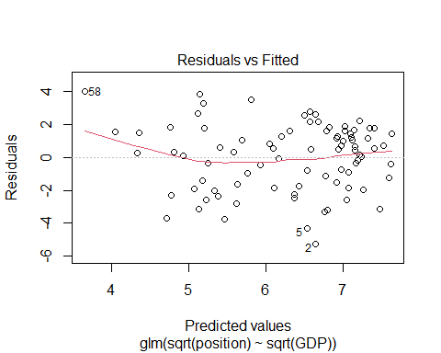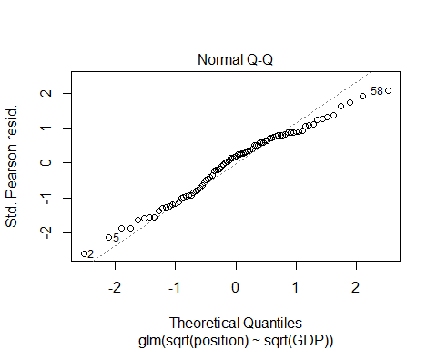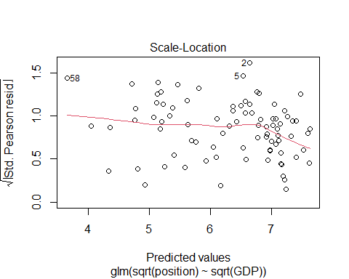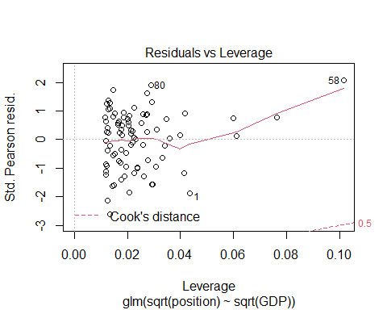

##mod7 - normal data  
mod7 <- glm(position ~ GDP, data=tokyo_GDP)  
plot(mod7)



##Logged data  
## fit a model where both the x and y are logged:  
mod8 <- glm(log10(position) ~ log10(GDP), data=tokyo_GDP)  
plot(mod8)

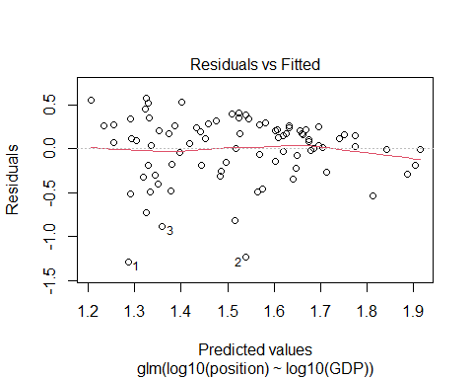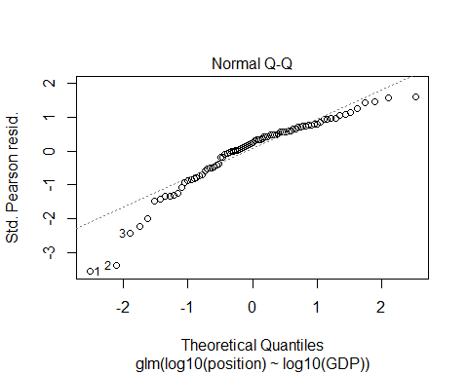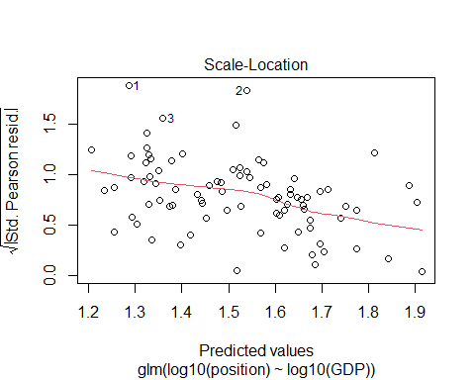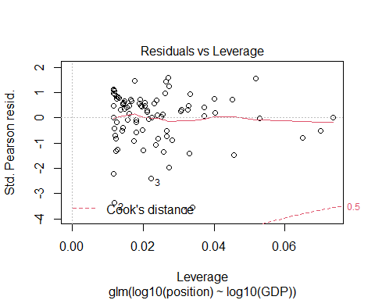

##compare them  
AIC_mods <- AIC(mod1, mod2, mod3,mod4, mod5, mod6,mod7, mod8)  
  
##rank them by AIC using the order() function  
AIC_mods[order(AIC_mods$AIC),]

## df AIC  
## mod8 3 76.45253  
## mod6 3 364.85035  
## mod4 3 781.07123  
## mod3 3 783.08610  
## mod1 3 787.00174  
## mod7 3 787.00174  
## mod5 3 855.04438  
## mod2 2 1722.33876

summary(mod8)

##   
## Call:  
## glm(formula = log10(position) ~ log10(GDP), data = tokyo_GDP)  
##   
## Deviance Residuals:   
## Min 1Q Median 3Q Max   
## -1.28583 -0.18705 0.09377 0.23851 0.57796   
##   
## Coefficients:  
## Estimate Std. Error t value Pr(>|t|)   
## (Intercept) 2.85553 0.31530 9.057 5.03e-14 ***  
## log10(GDP) -0.32810 0.07692 -4.266 5.25e-05 ***  
## ---  
## Signif. codes: 0 '***' 0.001 '**' 0.01 '*' 0.05 '.' 0.1 ' ' 1  
##   
## (Dispersion parameter for gaussian family taken to be 0.1373513)  
##   
## Null deviance: 13.899 on 84 degrees of freedom  
## Residual deviance: 11.400 on 83 degrees of freedom  
## (4 observations deleted due to missingness)  
## AIC: 76.453  
##   
## Number of Fisher Scoring iterations: 2

summary(mod6)

##   
## Call:  
## glm(formula = sqrt(position) ~ sqrt(GDP), data = tokyo_GDP)  
##   
## Deviance Residuals:   
## Min 1Q Median 3Q Max   
## -5.2331 -1.6297 0.3959 1.5250 3.9721   
##   
## Coefficients:  
## Estimate Std. Error t value Pr(>|t|)   
## (Intercept) 7.989789 0.445545 17.933 < 2e-16 ***  
## sqrt(GDP) -0.013274 0.003033 -4.376 3.49e-05 ***  
## ---  
## Signif. codes: 0 '***' 0.001 '**' 0.01 '*' 0.05 '.' 0.1 ' ' 1  
##   
## (Dispersion parameter for gaussian family taken to be 4.086555)  
##   
## Null deviance: 417.45 on 84 degrees of freedom  
## Residual deviance: 339.18 on 83 degrees of freedom  
## (4 observations deleted due to missingness)  
## AIC: 364.85  
##   
## Number of Fisher Scoring iterations: 2

##Homework part 2 iris data

library(tidyverse)  
library(multcomp)

## Loading required package: mvtnorm

## Loading required package: survival

## Loading required package: TH.data

## Loading required package: MASS

##   
## Attaching package: 'MASS'

## The following object is masked from 'package:dplyr':  
##   
## select

##   
## Attaching package: 'TH.data'

## The following object is masked from 'package:MASS':  
##   
## geyser

##View data  
data("iris")  
iris

## Sepal.Length Sepal.Width Petal.Length Petal.Width Species  
## 1 5.1 3.5 1.4 0.2 setosa  
## 2 4.9 3.0 1.4 0.2 setosa  
## 3 4.7 3.2 1.3 0.2 setosa  
## 4 4.6 3.1 1.5 0.2 setosa  
## 5 5.0 3.6 1.4 0.2 setosa  
## 6 5.4 3.9 1.7 0.4 setosa  
## 7 4.6 3.4 1.4 0.3 setosa  
## 8 5.0 3.4 1.5 0.2 setosa  
## 9 4.4 2.9 1.4 0.2 setosa  
## 10 4.9 3.1 1.5 0.1 setosa  
## 11 5.4 3.7 1.5 0.2 setosa  
## 12 4.8 3.4 1.6 0.2 setosa  
## 13 4.8 3.0 1.4 0.1 setosa  
## 14 4.3 3.0 1.1 0.1 setosa  
## 15 5.8 4.0 1.2 0.2 setosa  
## 16 5.7 4.4 1.5 0.4 setosa  
## 17 5.4 3.9 1.3 0.4 setosa  
## 18 5.1 3.5 1.4 0.3 setosa  
## 19 5.7 3.8 1.7 0.3 setosa  
## 20 5.1 3.8 1.5 0.3 setosa  
## 21 5.4 3.4 1.7 0.2 setosa  
## 22 5.1 3.7 1.5 0.4 setosa  
## 23 4.6 3.6 1.0 0.2 setosa  
## 24 5.1 3.3 1.7 0.5 setosa  
## 25 4.8 3.4 1.9 0.2 setosa  
## 26 5.0 3.0 1.6 0.2 setosa  
## 27 5.0 3.4 1.6 0.4 setosa  
## 28 5.2 3.5 1.5 0.2 setosa  
## 29 5.2 3.4 1.4 0.2 setosa  
## 30 4.7 3.2 1.6 0.2 setosa  
## 31 4.8 3.1 1.6 0.2 setosa  
## 32 5.4 3.4 1.5 0.4 setosa  
## 33 5.2 4.1 1.5 0.1 setosa  
## 34 5.5 4.2 1.4 0.2 setosa  
## 35 4.9 3.1 1.5 0.2 setosa  
## 36 5.0 3.2 1.2 0.2 setosa  
## 37 5.5 3.5 1.3 0.2 setosa  
## 38 4.9 3.6 1.4 0.1 setosa  
## 39 4.4 3.0 1.3 0.2 setosa  
## 40 5.1 3.4 1.5 0.2 setosa  
## 41 5.0 3.5 1.3 0.3 setosa  
## 42 4.5 2.3 1.3 0.3 setosa  
## 43 4.4 3.2 1.3 0.2 setosa  
## 44 5.0 3.5 1.6 0.6 setosa  
## 45 5.1 3.8 1.9 0.4 setosa  
## 46 4.8 3.0 1.4 0.3 setosa  
## 47 5.1 3.8 1.6 0.2 setosa  
## 48 4.6 3.2 1.4 0.2 setosa  
## 49 5.3 3.7 1.5 0.2 setosa  
## 50 5.0 3.3 1.4 0.2 setosa  
## 51 7.0 3.2 4.7 1.4 versicolor  
## 52 6.4 3.2 4.5 1.5 versicolor  
## 53 6.9 3.1 4.9 1.5 versicolor  
## 54 5.5 2.3 4.0 1.3 versicolor  
## 55 6.5 2.8 4.6 1.5 versicolor  
## 56 5.7 2.8 4.5 1.3 versicolor  
## 57 6.3 3.3 4.7 1.6 versicolor  
## 58 4.9 2.4 3.3 1.0 versicolor  
## 59 6.6 2.9 4.6 1.3 versicolor  
## 60 5.2 2.7 3.9 1.4 versicolor  
## 61 5.0 2.0 3.5 1.0 versicolor  
## 62 5.9 3.0 4.2 1.5 versicolor  
## 63 6.0 2.2 4.0 1.0 versicolor  
## 64 6.1 2.9 4.7 1.4 versicolor  
## 65 5.6 2.9 3.6 1.3 versicolor  
## 66 6.7 3.1 4.4 1.4 versicolor  
## 67 5.6 3.0 4.5 1.5 versicolor  
## 68 5.8 2.7 4.1 1.0 versicolor  
## 69 6.2 2.2 4.5 1.5 versicolor  
## 70 5.6 2.5 3.9 1.1 versicolor  
## 71 5.9 3.2 4.8 1.8 versicolor  
## 72 6.1 2.8 4.0 1.3 versicolor  
## 73 6.3 2.5 4.9 1.5 versicolor  
## 74 6.1 2.8 4.7 1.2 versicolor  
## 75 6.4 2.9 4.3 1.3 versicolor  
## 76 6.6 3.0 4.4 1.4 versicolor  
## 77 6.8 2.8 4.8 1.4 versicolor  
## 78 6.7 3.0 5.0 1.7 versicolor  
## 79 6.0 2.9 4.5 1.5 versicolor  
## 80 5.7 2.6 3.5 1.0 versicolor  
## 81 5.5 2.4 3.8 1.1 versicolor  
## 82 5.5 2.4 3.7 1.0 versicolor  
## 83 5.8 2.7 3.9 1.2 versicolor  
## 84 6.0 2.7 5.1 1.6 versicolor  
## 85 5.4 3.0 4.5 1.5 versicolor  
## 86 6.0 3.4 4.5 1.6 versicolor  
## 87 6.7 3.1 4.7 1.5 versicolor  
## 88 6.3 2.3 4.4 1.3 versicolor  
## 89 5.6 3.0 4.1 1.3 versicolor  
## 90 5.5 2.5 4.0 1.3 versicolor  
## 91 5.5 2.6 4.4 1.2 versicolor  
## 92 6.1 3.0 4.6 1.4 versicolor  
## 93 5.8 2.6 4.0 1.2 versicolor  
## 94 5.0 2.3 3.3 1.0 versicolor  
## 95 5.6 2.7 4.2 1.3 versicolor  
## 96 5.7 3.0 4.2 1.2 versicolor  
## 97 5.7 2.9 4.2 1.3 versicolor  
## 98 6.2 2.9 4.3 1.3 versicolor  
## 99 5.1 2.5 3.0 1.1 versicolor  
## 100 5.7 2.8 4.1 1.3 versicolor  
## 101 6.3 3.3 6.0 2.5 virginica  
## 102 5.8 2.7 5.1 1.9 virginica  
## 103 7.1 3.0 5.9 2.1 virginica  
## 104 6.3 2.9 5.6 1.8 virginica  
## 105 6.5 3.0 5.8 2.2 virginica  
## 106 7.6 3.0 6.6 2.1 virginica  
## 107 4.9 2.5 4.5 1.7 virginica  
## 108 7.3 2.9 6.3 1.8 virginica  
## 109 6.7 2.5 5.8 1.8 virginica  
## 110 7.2 3.6 6.1 2.5 virginica  
## 111 6.5 3.2 5.1 2.0 virginica  
## 112 6.4 2.7 5.3 1.9 virginica  
## 113 6.8 3.0 5.5 2.1 virginica  
## 114 5.7 2.5 5.0 2.0 virginica  
## 115 5.8 2.8 5.1 2.4 virginica  
## 116 6.4 3.2 5.3 2.3 virginica  
## 117 6.5 3.0 5.5 1.8 virginica  
## 118 7.7 3.8 6.7 2.2 virginica  
## 119 7.7 2.6 6.9 2.3 virginica  
## 120 6.0 2.2 5.0 1.5 virginica  
## 121 6.9 3.2 5.7 2.3 virginica  
## 122 5.6 2.8 4.9 2.0 virginica  
## 123 7.7 2.8 6.7 2.0 virginica  
## 124 6.3 2.7 4.9 1.8 virginica  
## 125 6.7 3.3 5.7 2.1 virginica  
## 126 7.2 3.2 6.0 1.8 virginica  
## 127 6.2 2.8 4.8 1.8 virginica  
## 128 6.1 3.0 4.9 1.8 virginica  
## 129 6.4 2.8 5.6 2.1 virginica  
## 130 7.2 3.0 5.8 1.6 virginica  
## 131 7.4 2.8 6.1 1.9 virginica  
## 132 7.9 3.8 6.4 2.0 virginica  
## 133 6.4 2.8 5.6 2.2 virginica  
## 134 6.3 2.8 5.1 1.5 virginica  
## 135 6.1 2.6 5.6 1.4 virginica  
## 136 7.7 3.0 6.1 2.3 virginica  
## 137 6.3 3.4 5.6 2.4 virginica  
## 138 6.4 3.1 5.5 1.8 virginica  
## 139 6.0 3.0 4.8 1.8 virginica  
## 140 6.9 3.1 5.4 2.1 virginica  
## 141 6.7 3.1 5.6 2.4 virginica  
## 142 6.9 3.1 5.1 2.3 virginica  
## 143 5.8 2.7 5.1 1.9 virginica  
## 144 6.8 3.2 5.9 2.3 virginica  
## 145 6.7 3.3 5.7 2.5 virginica  
## 146 6.7 3.0 5.2 2.3 virginica  
## 147 6.3 2.5 5.0 1.9 virginica  
## 148 6.5 3.0 5.2 2.0 virginica  
## 149 6.2 3.4 5.4 2.3 virginica  
## 150 5.9 3.0 5.1 1.8 virginica

#Plot Petal.width split by pethal width so we can visualise if there are effects  
##and if this differs amongst the three species  
petal_width <- ggplot(data=iris,  
 aes(x= Petal.Length, y=Petal.Width)) +  
 geom_point(aes(col=Species)) +   
 theme_bw()   
  
##Linear regression to visualise effects  
##plotting a different LM for species  
  
petal_width + geom_smooth(aes(col=Species), method="lm")

## `geom_smooth()` using formula 'y ~ x'

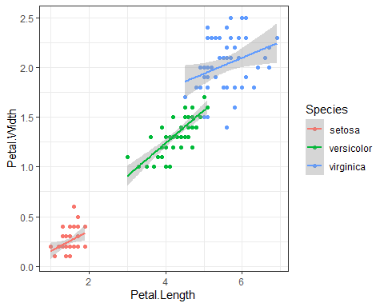

##fit a glm()  
mod_pet_width <- glm(Petal.Width ~ Petal.Length*Species,  
 ##specify the data  
 data = iris,  
 ##specify the error structure  
 family = "gaussian")  
plot(mod_pet_width)

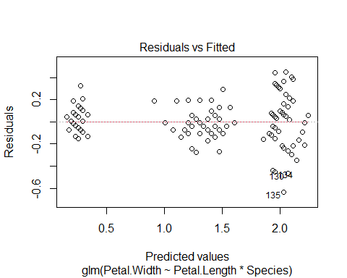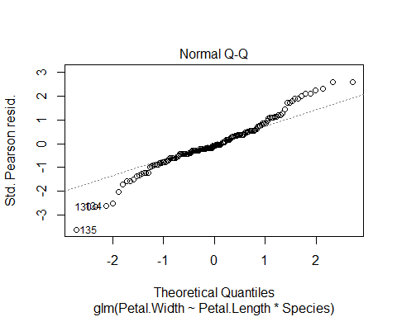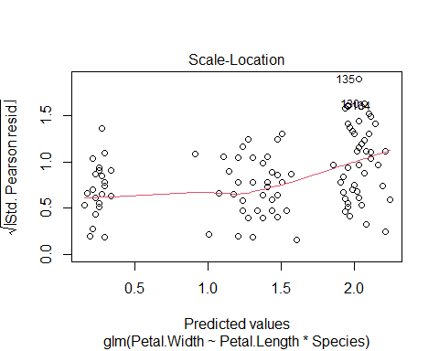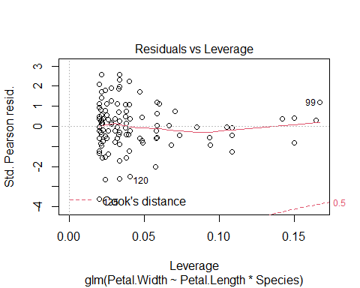

##log10() single mod  
mod_log <- glm(log(Petal.Width) ~ Petal.Length*Species,  
 ##specify the data  
 data = iris)  
plot(mod_log)

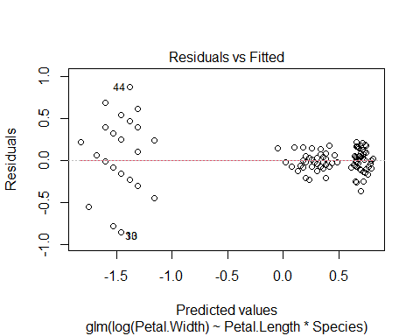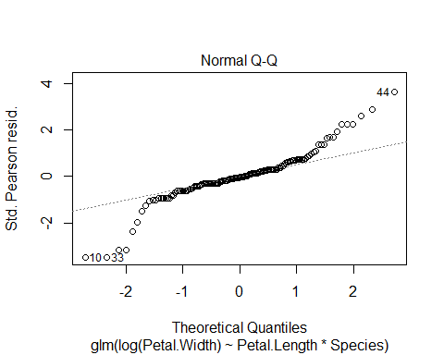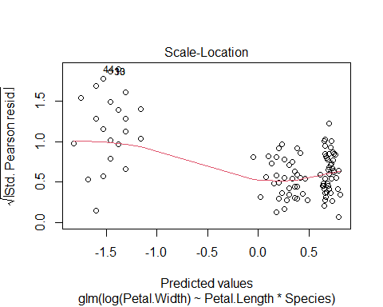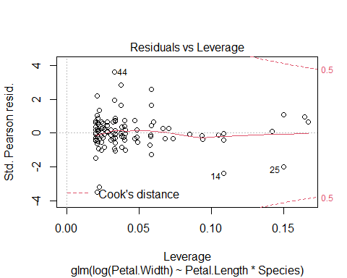

##sqrt() mod  
mod_sqrt <- glm(sqrt(Petal.Width) ~ Petal.Length*Species,  
 ##specify the data  
 data = iris)  
plot(mod_sqrt)

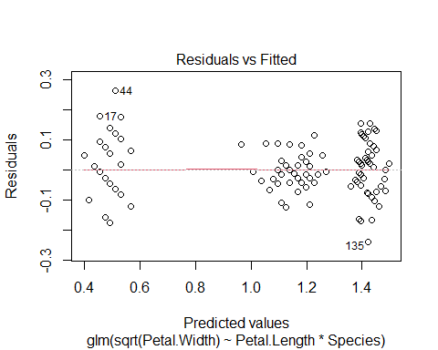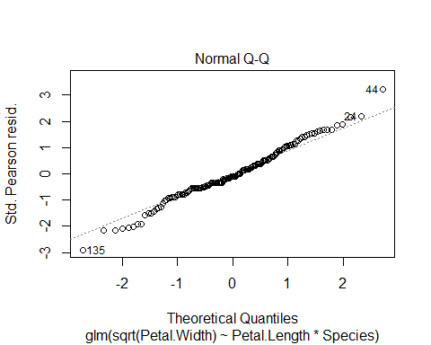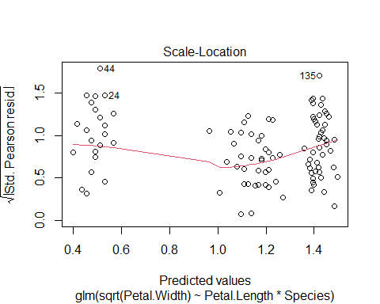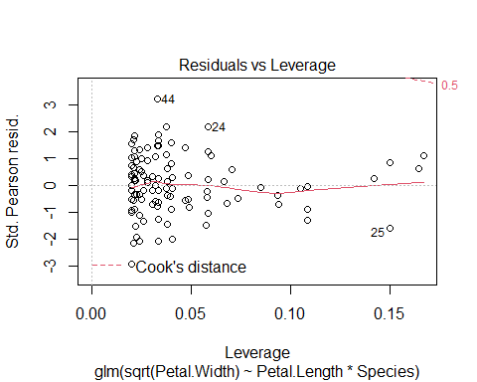

##Residuals vs Fitted   
##graph shows a better distribution than mod log and gaussian log  
##graph does not shows a clear trend  
##Normal Q-Q: Values are close to the dotted line  
##Scale-Location: Better dsitribution than the other models, no heteroskedasticity  
##red line is roughly horizontal better line than the other methods.  
##Residuals vs Leverage: No points outside the 0.5 lines  
  
  
##compare the models  
AIC_mods <- AIC(mod_pet_width, mod_log, mod_sqrt)  
  
##rank them by AIC using the order() function  
AIC_mods[order(AIC_mods$AIC),]

## df AIC  
## mod_sqrt 7 -311.93180  
## mod_pet_width 7 -85.39086  
## mod_log 7 11.88816

##summary  
summary(mod_sqrt)

##   
## Call:  
## glm(formula = sqrt(Petal.Width) ~ Petal.Length * Species, data = iris)  
##   
## Deviance Residuals:   
## Min 1Q Median 3Q Max   
## -0.23961 -0.04583 -0.00825 0.04838 0.26267   
##   
## Coefficients:  
## Estimate Std. Error t value Pr(>|t|)   
## (Intercept) 0.20974 0.10091 2.079 0.03943 *   
## Petal.Length 0.18887 0.06855 2.755 0.00662 **   
## Speciesversicolor 0.31788 0.14821 2.145 0.03365 *   
## Speciesvirginica 0.89496 0.15704 5.699 6.57e-08 ***  
## Petal.Length:Speciesversicolor -0.04317 0.07308 -0.591 0.55565   
## Petal.Length:Speciesvirginica -0.13206 0.07186 -1.838 0.06816 .   
## ---  
## Signif. codes: 0 '***' 0.001 '**' 0.01 '*' 0.05 '.' 0.1 ' ' 1  
##   
## (Dispersion parameter for gaussian family taken to be 0.006943608)  
##   
## Null deviance: 24.42219 on 149 degrees of freedom  
## Residual deviance: 0.99988 on 144 degrees of freedom  
## AIC: -311.93  
##   
## Number of Fisher Scoring iterations: 2

##whether there is an overall effect of Petal.Length on Petal.Width  
##whether there is an overall effect of Species on Petal.Width  
##whether there is a difference in the magnitude of the Petal.Length on Petal.Width between different species  
##i.e. does the slope of the effect of Petal.Length on Petal.Width change between different species.